Test Engineer Quiz

* Time to complete is 24 hours from receiving the test
* Answers are to be typed up in a report format, scripts are to be added as appendices
* The report is to be returned via email in a .pdf format
* State all assumptions where they have been made

------------------------------------------------------------ Test Is Below ---------------------------------------------------------------

# Industrial Hardware

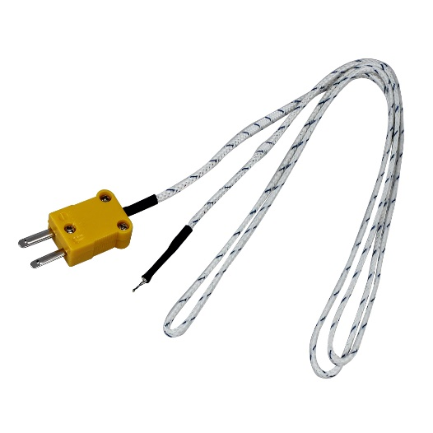Name the following items and provide an example of a typical industrial application for each one.

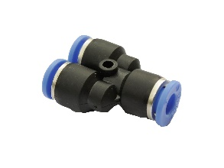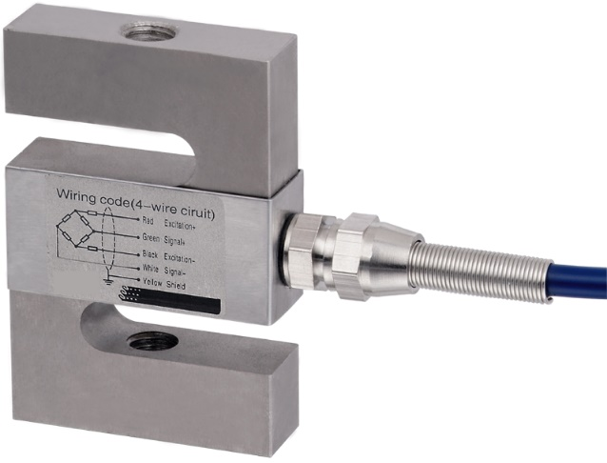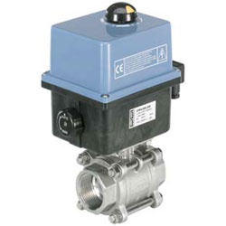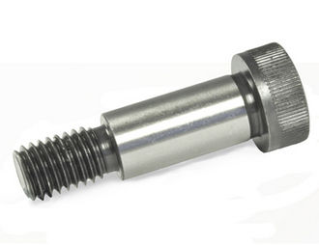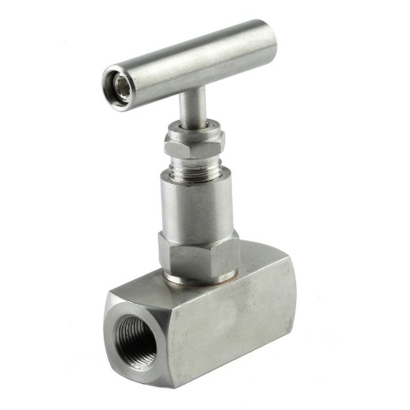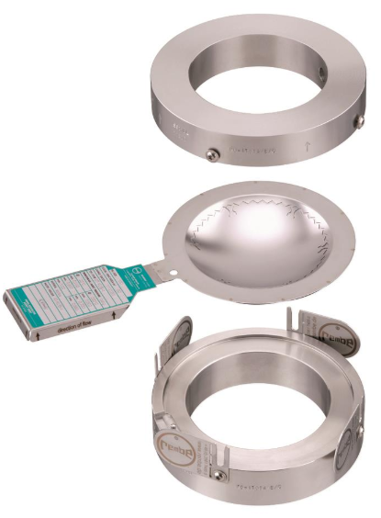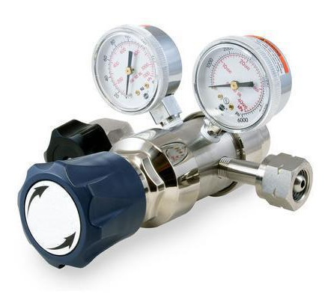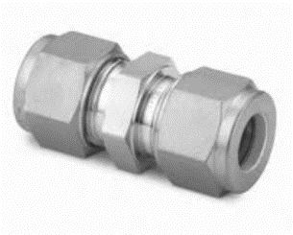

a.

b.

c.

d.

e.

f.

g.

h.

i.

# Sensors and Instrumentation

2a) Four data measuring devices P1, P2, Q and T are used to take measurements of a system. What is the resultant percentage and absolute uncertainty in the calculated values X and Y when using the measurements from the devices? Assume all sensor measurements are within their range.

X = P1xT

Y = ((P1+P2)/Q)^2

|  |  |  |  |
| --- | --- | --- | --- |
| Sensor | Description | Range | Uncertainty (% full scale range) |
| P1 | Pressure sensor | 0 - 10.0 MPa | 0.5% |
| P2 | Pressure sensor | 0 - 5.0 MPa | 2% |
| Q | Flow sensor | 0 - 500 L/min | 1% |
| T | Temperature sensor | 0 - 500 K | 4% |

2b) A differential pressure sensor with a 4-20 mA output has a measuring range of 0 – 10 bar is measured on an 8bit resolution data logger. The sensor has a ± 0.05 bar absolute accuracy and the full scale input of the data logger is 4-20 mA. What will be the pressure reading and uncertainty in bar (pressure) be when the sensor is reading a differential pressure of 80 metres of water head? Assume 1000kg/m^3 density for the water.

# Question Assuming using some NI 9237 module:

3(a) Specify wiring connections to connect the following [MT501 load cell](https://cdn.shopify.com/s/files/1/0928/8178/files/MT501.pdf?9057575588948678356) to a [NI 9237](http://www.ni.com/pdf/manuals/374186a_02.pdf) module. Assume the D-Sub module version and that you are connecting to channel 1.

3(b) State the gain uncertainty of the card, assuming you are sampling one channel at 1.6kHz. How would you further improve the estimate of gain?

3(c) Attached is data recorded from loading and unloading calibrated masses. Determine the load cell sensitivity.

Data file = LoadCellCal.csv

# Engineering

4a) what is the saturated fluid temperature of liquid oxygen at a pressure of 7 bar?

4b) which has greater energy density and why when comparing methanol and diesel combusting in air?

4c) I have an electric motor that produces 0.4 HP of shaft power at a speed of 2800rpm. What will the gearbox speed and torque be on the output of a 1:5 (in:out) gearbox? Assume a 96% efficient gearbox

4d) design a shaft that is 100mm long to transmit the gearbox output torque of the above problem using sensible engineering assumptions. Select a material and design the diameter.

4e) assume that you have a centrifugal pump impeller at the end of the shaft you designed in the above problem. What will be the maximum deflection at the tip of the centrifugal impeller with respect to the shaft? Assume that the impeller is rigid (does not deflect) and has a diameter of 100mm. Assume all deflection is from the 100mm long shaft only.

# Data Processing

Process the attached data set with a python script to do the following:

5(a) Import the data into memory

Data file = TestData.csv

5(b) Plot the time history if each column separately with the following traces for each column:

* Straight time history
* 50 point moving average
* Filtered with an FIR with a cutoff frequency of 100Hz.
  + Have filtered data time adjusted so that the original and filtered time histories overlap.
  + State the roll off of the filter.
* A horizontal lines indicating the mean and ± 2 std-dev lines

5(c) Plot column A vs Column B

* Fit a linear trend line and annotate (using the script) the plot with the equation of the line and R^2 value.

5(d) Perform an FFT on Column C and plot the power spectrum.

* Identify the frequency with the strongest component
* Specify the approximate cut-off (corner) frequency for a first order low pass butterworth filter such that the component at 500Hz is attenuated by roughly 20dB.